Nama : Salsabil Hafadz Muttaqin

Nim : 192410103079

Kelas : Perancangan Website IF A

ScreenShoot File HTML

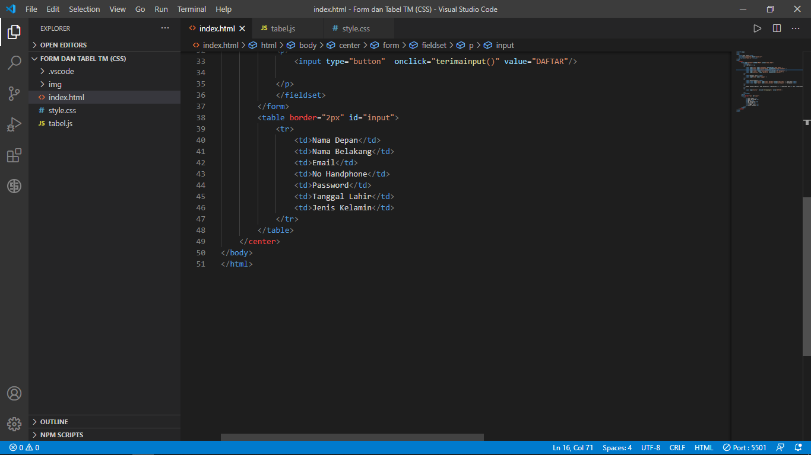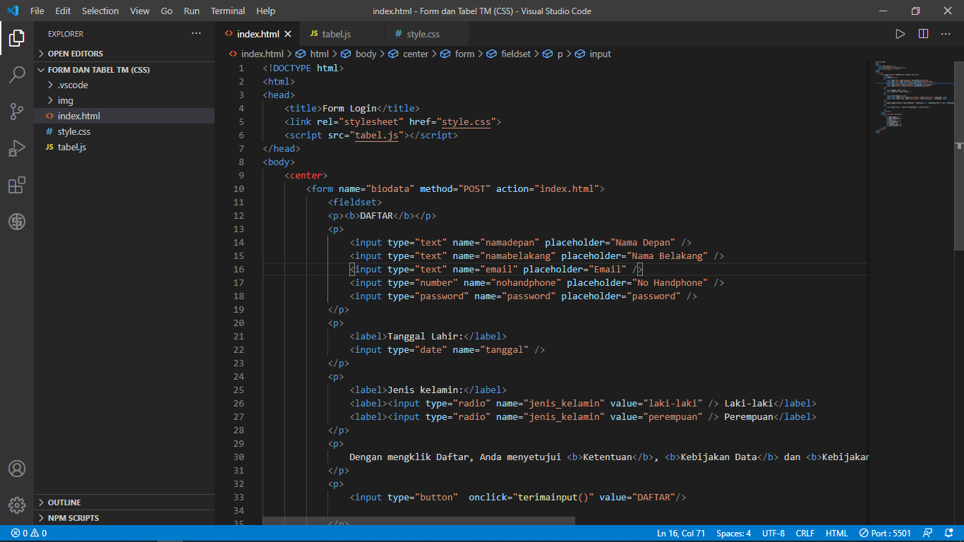

ScreenShoot File CSS

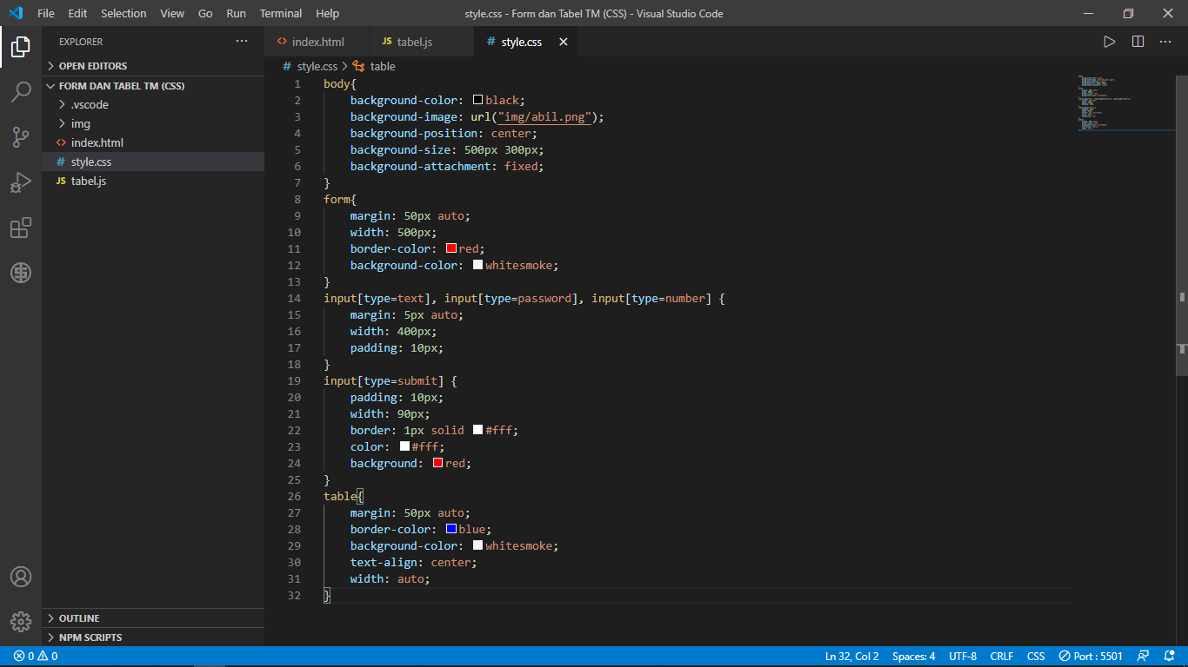

ScreenShoot File JavaScript

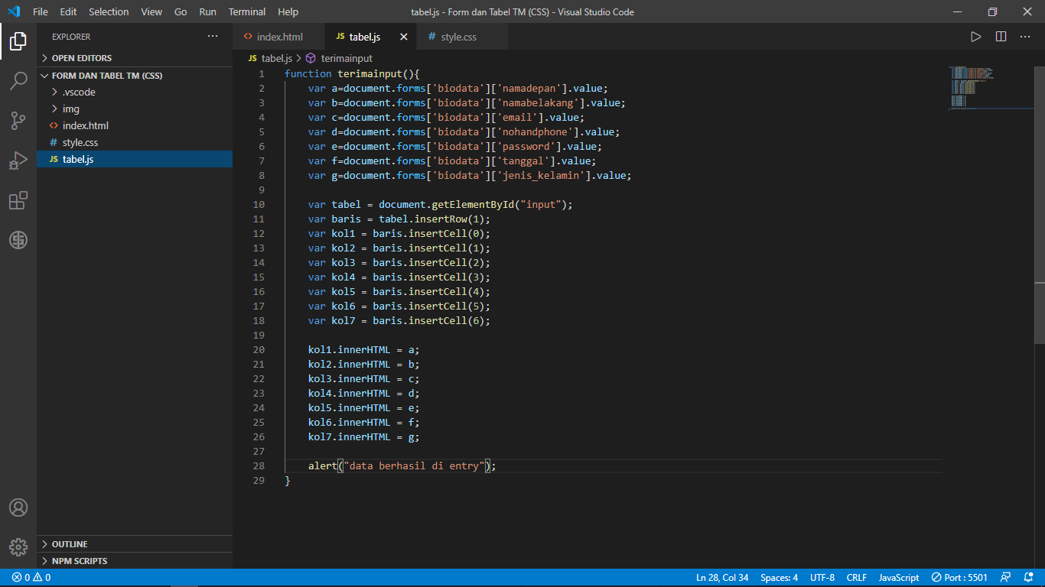

ScreenShoot Hasil

